**Name: Shaunak Deshpande**

**Div.: TY-IC-C**

**Roll. No.: 39**

**GR no.: 11911180**

**Batch.: 2**

### Title: Process Simulation.

The workshop is based on simulation of a spray dryer. The drying mechanism within the spray tower is quite complex. It is impacted by the slurry flow rate, the spray pressure, the air flow and the air temperature. The spray dryer process and its associated controls are shown below.

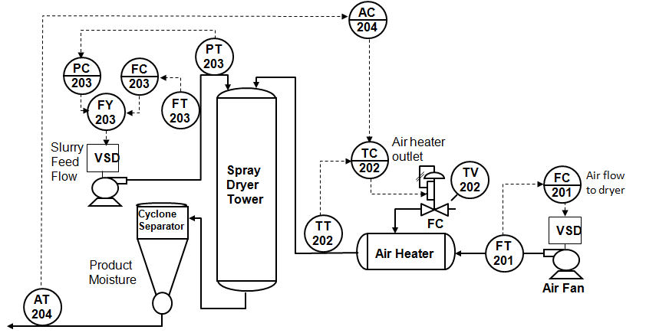

### Steps:

Step 1. In the Process Simulation workspace, change the slurry flow setpoint and observe how the heater outlet temperature is automatically adjusted to maintain the product moisture at setpoint.

Step 2. Place the heater temperature control in manual and then make a change in the slurry flow setpoint. Try to manually adjust the temperature controller output to correct for this change in slurry flow. Place the heater temperature control in Cascade mode and observe how the product moisture is brought back to setpoint.

### 

**Step 1.** In the Process Simulation workspace, change the slurry flow setpoint and observe how the heater outlet temperature is automatically adjusted to maintain the product moisture at setpoint.

Change Setpoint from 6 to 7.

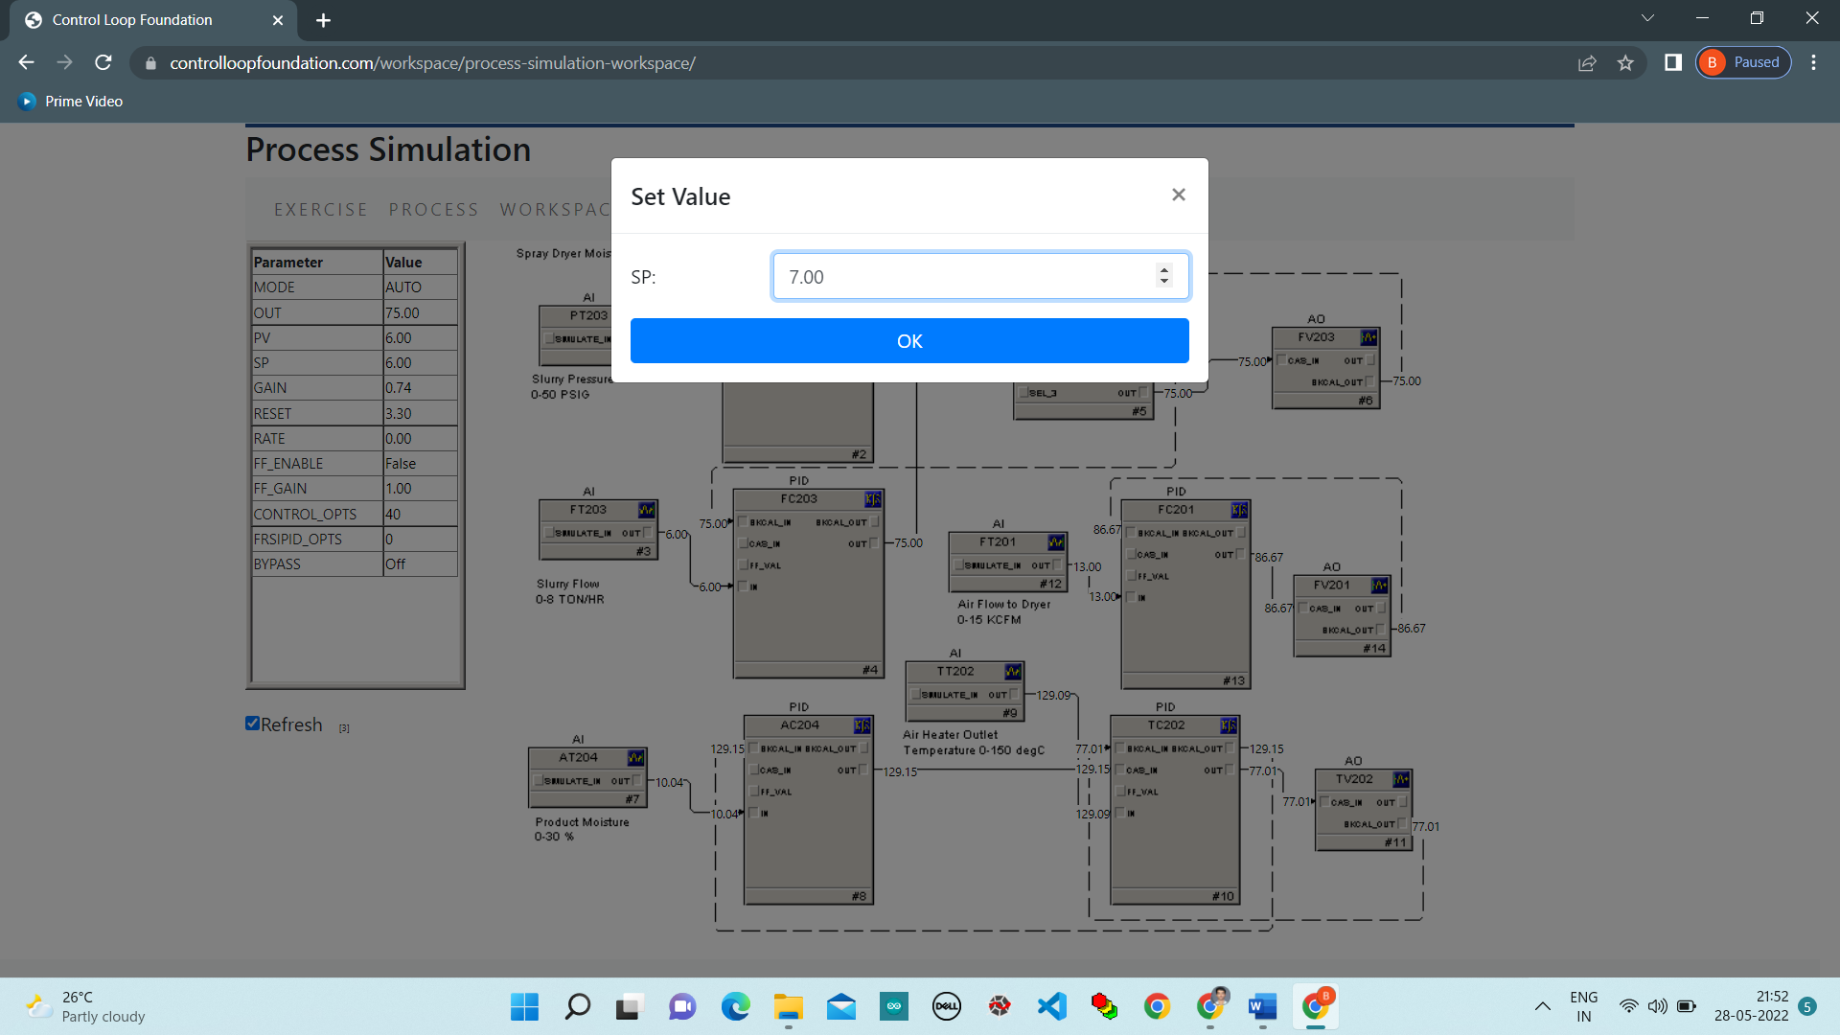

### Chart:

### 

### Change Mode of PID from Cascade to Manual.

### 

### Change Setpoint of PID from 7 to 6.

### 

### Chart:

### 

**Step 2.** Place the heater temperature control in manual and then make a change in the slurry flow setpoint. Try to manually adjust the temperature controller output to correct for this change in slurry flow. Place the heater temperature control in Cascade mode and observe how the product moisture is brought back to setpoint.

### 

### Change output of PID from 84.70 to 80.

### 

### Change Mode of PID from Manual to Cascade.

### 

### Chart:

### 

**Conclusion:**

In this lab we studied about how to demonstrate the operation of a sprayer dryer using the dynamic process simulation and performed through the controlloop foundation workshop and observe the response.